Michael S. Corak, Kevin P. Hartzog, Fisher A. Hillburn, Jordan K. Weid

FAMU-FSU College of Engineering  2525 Pottsdamer St. Tallahassee, FL. 32310

Team 514: Develop a Hydrogen Pre-Heater in the Nuclear Rocket Simulation

10/2/2020



# Abstract

The abstract is a concise statement of the significant contents of your project. The abstract should be one paragraph of between 150 and 500 words. The abstract is not indents.

*Keywords*: list 3 to 5 keywords that describe your project.

# Disclaimer

Your sponsor may require a disclaimer on the report. Especially if it is a government sponsored project or confidential project. If a disclaimer is not required delete this section.

# Acknowledgement

These remarks thanks those that helped you complete your senior design project. Especially those who have sponsored the project, provided mentorship advice, and materials. 4

* Paragraph 1 thank sponsor!
* Paragraph 2 thank advisors.
* Paragraph 3 thank those that provided you materials and resources.
* Paragraph 4 thank anyone else who helped you.

Table of Contents

Abstract ii

Disclaimer iii

Acknowledgement iv

List of Tables vii

List of Figures viii

Notation ix

Chapter One: EML 4551C 1

1.1 Project Scope 1

1.2 Customer Needs 3

1.3 Functional Decomposition 7

Introduction 7

Discussion of Data Generation 7

Action and Outcome 8

Hierarchy Chart 8

Discussion 9

Connection to Systems 11

Smart Integration 12

1.4 Target Summary 13

Critical Targets and Metrics 13

Critical Functions 14

Summary and Derivation of Targets and Metrics 14

Derivation and Validation of Non-Critical Functions 16

1.5 Concept Generation 18

1.6 Concept Selection 27

1.8 Spring Project Plan 27

Chapter Two: EML 4552C 28

2.1 Spring Plan 28

Project Plan. 28

Build Plan. 28

Appendices 29

Appendix A: Code of Conduct 30

Appendix B: Concept Generation 34

Appendix C: Target Catalog 35

Appendix D: Poop 36

References 37

# List of Tables

Table 1 *The Word Table and the Table Number are Normal Font and Flush Left. The Caption is Flush Left, Italicized, Uppercase and Lowercase* 10

# List of Figures

Figure 1. Flush left, normal font settings, sentence case, and ends with a period. 9

# Notation

|  |  |
| --- | --- |
| A17 | Steering Column Angle |
| A27 | Pan Angle |
| A40 | Back Angle |
| A42 | Hip Angle |
| AAA | American Automobile Association |
| AARP | American Association of Retired Persons |
| AHP | Accelerator Heel Point |
| ANOVA | Analysis of Variance |
| AOTA | American Occupational Therapy Association |
| ASA | American Society on Aging |
| BA | Back Angle |
| BOF | Ball of Foot |
| BOFRP | Ball of Foot Reference Point |
| CAD | Computer Aided Design |
| CDC | Centers for Disease Control and Prevention |
| CU-ICAR | Clemson University - International Center for Automotive Research |
| DDI | Driver Death per Involvement Ratio |
| DIT | Driver Involvement per Vehicle Mile Traveled |
| Difference | Difference between the calculated and measured BOFRP to H-point |
| DRR | Death Rate Ratio |
| DRS | Driving Rehabilitation Specialist |
| EMM | Estimated Marginal Means |
| FARS | Fatality Analysis Reporting System |
| FMVSS | Federal Motor Vehicle Safety Standard |
| GES | General Estimates System |
| GHS | Greenville Health System |
| H13 | Steering Wheel Thigh Clearance |
| H17 | Wheel Center to Heel Pont |
| H30 | H-point to accelerator heel point |
| HPD | H-point Design Tool |
| HPM | H-point Machine |
| HPM-II | H-point Machine II |
| HT | H-point Travel |
| HX | H-point to Accelerator Heel Point |
| HZ | H-point to Accelerator Heel Point |
| IIHS | Insurance Institute for Highway Safety |
| L6 | BFRP to Steering Wheel Center |
|  |  |
|  |  |
|  |  |

# Chapter One: EML 4551C

## Project Scope

**Project Description**

This project was designated to solve the problem at the NASA Nuclear Thermal Rocket test facility for the lack of inlet temperature control of hydrogen gas into a test chamber. The design will result in a device which allows for user control of incoming hydrogen temperature for a better interaction between the hot gas and test material.

**Key Goals**

The objective of the design is to allow for independent control of the inlet temperature of hydrogen supply to the test articles. Additionally, the aim is to have a broad range of control over the pre-heater, while allowing users to easily measure the surrounding conditions. The team is striving to have a robust system that can handle extreme environments as well as integrating with surrounding subsystems without negative effects. Another goal is to communicate bi-weekly with the sponsor for progress updates and future direction.

**Markets**

Our product is being designed directly for NASA’s Marshall Space Flight Center (MSFC) Nuclear Thermal Rocket test facility, so NASA is our primary market. Industries that could benefit from our design include the following: induction heating, nuclear propulsion labs, aerospace research labs, material processing facilities, electric appliance companies, and plastics processing facilities.

**Assumptions**

The following assumptions help to simplify design so that scope is well defined and will not expand throughout the project. Due to the nature of the design, most of the assumptions are based on the simplification of the physics involved. It is assumed that the design will not control pressure and flow rate of the hydrogen. Additionally, compressibility effects will be assumed to be negligible to make the modeling of the problem simpler. Another assumption is that all heat transfer in the hydrogen will occur inside of the testing region and that radiation effects will not be accounted for. To maintain a feasible timeline, the conceptual design will be assumed to be finished by the end of the fall semester and for spring, manufacture and testing will be completed.

**Stakeholders**

The stakeholders in this project are the sponsor of NASA MSFC, academic adviser Dr. Kumar, senior design professor Dr. McConomy, and eventual operators of the design. The project sponsor has stake in the project as he is providing all funding for the design, has interest in using it, and has control over the project’s direction. Dr. Kumar has stake in the project as well because he will be spending his time and knowledge in guiding the team through the challenges of the design. Dr. McConomy is the professor who will be overseeing the entire project and has invested considerable time and effort into securing sponsors for each senior design project, and can provide direction. Dr. McConomy has staked his reputation with the sponsor organization by giving us responsibility in the project. Operators of the design at NASA MSFC are considered to hold stake in the project, as they have interest in using it. The NASA MSFC facility also directly benefits from the project. The team itself holds stake because there is direct control, interest, and time investment.

## 1.2 Customer Needs

**Method of Gathering Customer Needs**

Prior to meeting with the sponsor, Mike Schoenfeld, the team formulated a rough list of questions that were general enough as to not be exposed to too many specifics early on. These questions were designed to get an idea of the scope of the project and to become familiar with the nomenclature involved with the design. The team asked direct questions that allowed for responses that answered “what” not “how”.

Therefore, questions were posed at learning more about the physical conditions that the design will be exposed to, and the limits of the design space. The interpreted needs from the design’s physical conditions is that pressures and temperatures will be monitored and that the geometry and physics of the heating are parameters that can be controlled. Furthermore, for the design space the interpreted need is that the design can be used in the testing chamber.

Questions were also brought up about issues with the existing conditions. Then, some basic questions about broader engineering categories such as heat transfer, fluid dynamics, and physics were asked to narrow down the fields of engineering that will be used during the project. After the meeting, the team discussed key takeaways and formulated more specific questions. These questions were emailed to the sponsor so that more time could be spent on the answers. These questions were directed at understanding the subsystems the design might interact with to form a functional decomposition. Some other questions were posed at understanding the underlying physics of the problem.

The interpreted needs taken from these questions framed some specifics about the instrumentation and measurement devices that can be used, and the nature of the hydrogen’s interaction with the test devices. As far as the materials science of this design, the sponsor was clear about what is needed.

**Synthesis of Customer Data Table**

|  |  |  |
| --- | --- | --- |
| **Question** | **Customer Response** | **Interpreted Need** |
| What design space is the heat exchanger restricted to? | Within test chamber, where the other heaters are located. | The design can be incorporated into the existing test space. |
| What parameters will the group have control over? | Power delivered to induction coils, geometry of coil. | The design accounts for the power delivered and geometry of the preheater. |
| How do the current test articles differ from true nuclear heating? | Nuclear heating is a volumetric heating phenomenon, whereas induction heating is a surface heating phenomenon. | The test articles will be heated by induction. |
| Does the hydrogen gas undergo any appreciable compression before it reaches the test articles? | No, there is turbomachinery to move the fluid, but doesn’t undergo significant compression. | The design neglects compressibility effects. |
| Will radiation be modeled? | No |  |
| What flow physics will be considered? | Heat transfer, not so much fluid dynamics. |  |
| What are the desired temperatures at outlet of test chamber? | 2000-2500 K. | The fluid can be heated to around 2000-2500 K at the outlet of the heat exchanger. |
| What effect does hot hydrogen have on the vessels that enclose it? | It is highly corrosive. |  |
| What issue does the absence of hydrogen pre-heating cause? | Without hydrogen pre-heating, the hydrogen temperatures in the furnace will depend on the test article temperature and heat exchange efficiencies.  The intent of the test article is to be exposed to hot, flowing hydrogen.  Thus, the capability to independently control the hydrogen conditions is needed.  Currently the facility can control pressures and flow rates.  What is remaining is the inlet temperature. | The design allows for independent temperature control. |
| Is the goal to increase the temperature of the hydrogen to the desired temp in a smoother fashion so that deltaT of inlet of normal heaters is less, rather than large deltaT of cold hydrogen to hot test article? | Not really. More about controlling the temperature of the hydrogen the test article is exposed to. | The design can heat the hydrogen to a specific temperature. |
| Is the inlet mass flow rate fixed to a specific value, and if so, is it independently controlled? | The inlet mass flow rate is throttled. The facility can provide H2 mass flow rates from about 0.1 – 1,000 g/s. |  |
| Is the corrosion caused by the hot hydrogen acceptable to a certain point? | That criterion is set by the test article designer and the people using the test articles. Our focus is to create the correct exposure conditions and monitor for the corrosion via sampling streams that go to a mass spectrometer to examine composition. | The design monitors physical conditions. |
| Why is the design space restricted to inside the test chamber? | For safety reasons, we prefer to contain the hydrogen and any potential leaks inside the chamber. Material strengths are weaker at elevated temperatures so having a high-pressure supply tube be hot is not a comfortable prospect. |  |
| What additional measurement devices are required in the pre-heater? | I’m open to recommendations. I would think in general anything related to performance. Inlet and outlet temperature come to mind. Inlet and outlet pressures or pressure drop as well. Knowing power deposition, it would be beneficial but if we used induction heating that would come from the heater equipment really. | Temperature and pressure are able to be measured. |
| Are the existing induction coils made in house or from a supplier? | Currently from a supplier; fluxtrol. |  |
| What material are the existing induction coils? | Copper tubes. |  |
| What is the material of the test article (the tube the Hydrogen flows through)? | They vary from refractory metal alloys (cermets) to ceramics (carbides) to graphite. | The design uses materials with high melting temperature and high thermal conductivity . |
| What is the desired outlet temperature of pre-heater? | ~2,200 K would be a good target to shoot for. It may be useful to know that we currently have an induction heater that is rated for 12.5 kW, if we buy another one and repurpose our current one, it is rated to 1.2 MW. We are pulling power from a substation that can provide no more than 10 MW. | The design displays power usage. |

## 1.3 Functional Decomposition

# Introduction

The functional decomposition breaks down the complete problem into systems designed to perform fundamental actions that come together to resolve the problem at hand. The problem is NASA does not have a way to independently control the temperature of the incoming hydrogen when it reaches the test articles. The resolution was to design a device that will allow NASA to set the inlet hydrogen temperature to a desired value. With the use of gathered customer needs and considering the key goals of the project, the functional decomposition of a hydrogen pre-heater was created. With the aid of a hierarchy chart and cross-reference chart, the functional decomposition was diagnosed. Using the cross-reference chart, connections between the systems and their functions could be found and further investigated to see which are most important. This helps to narrow down the design process and get a clearer scope of how the problem will be solved.

# Discussion of Data Generation

Data for the functional decomposition was generated based on the responses from the customer needs and the project scope. These requirements were then split into their most basic subsystems needed for the system to operate. According to the customer needs, the hydrogen needs to be independently heated upon entering the test chamber. Furthermore, the customer also states that the parameters to be controlled are the power delivered and the geometry of the coils. From this, the functions of the device were specified, and the hierarchy chart and cross-reference table were constructed.

# Action and Outcome

The goal of the project is to pre-heat the inlet hydrogen in the test chamber. The device will allow for different inlet temperatures to be set based on customer needs. The device will have an interface that allows the user to input a desired temperature and the control device will modulate the heating device to achieve the required hydrogen temperature.

# Hierarchy Chart

Using all the data and information listed above, the team was to create a hierarchy chart based on the needed systems and functions. The hierarchy chart is a flow chart starting with our problem and breaking down into systems and fundamental functions that need to be achieved to solve the problem at hand. Below is our hierarchy chart for our problem: creating a hydrogen pre-heater for NASA’s test chamber.

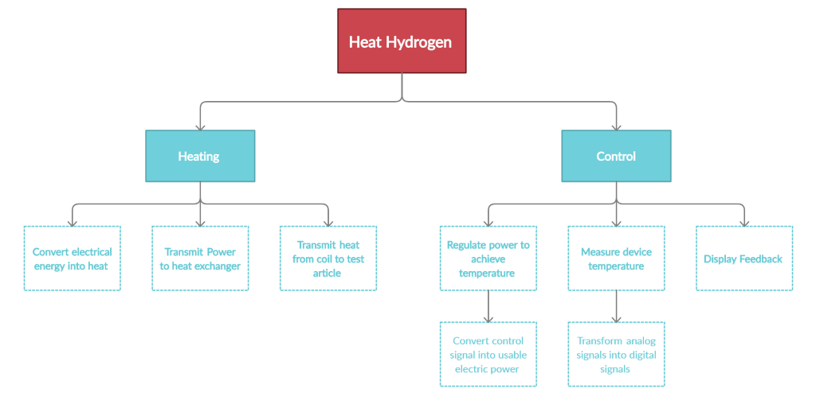

## Discussion

The following hierarchy charts shows the system and its related subsystems, in descending order of specific functions. The subsystems were split into their constituent parts by reviewing the customer statements to get an idea of all the relevant functions. The main function is to independently control the temperature of the hydrogen at the inlet, so the first system is termed “heat hydrogen”. The two primary subsystems branch off into controlling the temperature and the physical means of heating. The first step in heating the hydrogen is to provide power from an external source and transmit it to the induction coils that surround the test article. Then, the heat must also be transmitted from the induction coil to the test article, so this is a function. The controller subsystem works with the heating device subsystem in that it is the decision-making part of the design. A controller is essential in determining the power output of the heating device. This is the reasoning for the modulation of power subsystem. Measurement devices are also required in any traditional controller because it provides the user or computer program information about the environment to be able to make decisions. This is also the reasoning behind the controller displaying feedback, because it is important for diagnosis. It should be noted that the induction coil is repeatedly specified as the heat transfer device because the scope of the project does not include design freedom of the type of heat transfer device.

**Cross Reference Chart**

The cross-reference chart indicates which systems fulfil which of the fundamental functions needed to resolve the problem of the project. For our cross-reference chart, we chose “Heating” and “Control” as our systems since these systems are the fundamental ones needed for the device.



## Connection to Systems

From the cross-reference table, it can be concluded that the “control” system is the most important to the project, as it fulfils 6 functions. Therefore, it is the highest ranked system. This makes sense because the control system is the priority for decision making in the entire project. Although the heat system is important, most of its subsystems are constrained by simpler concepts like material properties and physics. The control system requires more attention because of its complex subsystems like data processing and conversion of electrical signals. The subsystems of control largely influence the goal of providing feedback through measurement and display of electrical signals. Measurement of the environment and providing feedback was a top priority. The heating system is the backbone of providing an actual temperature difference in the system. Therefore, it is a priority as well. Its relation to the resulting subsystems involves the delivery of electrical power to usable heat. The heating system is also governed by simple equations like the equations of heat transfer and power from current through a wire. Therefore, heating is the second highest ranked system.

# Smart Integration

The cross-reference table also provides a display of the relationships between subsystems and allows the investigation for any possible integration of subsystems. Since heating and control require that both systems work in unison, overlap of functions is expected. For example, the regulation of power is a function that is directly related to heat output, but regulation implies change, which requires some sort of control. Since there are nonlinear energy losses present in the physics of the problem, the functions might be integrated by forming linear relationships to proportionally link change in power to heat output. Converting electrical energy to inductive heating also experiences overlap, mostly because electrical energy normally produces standard resistive heating. The project uses eddy current heating, or induction heating where the properties of the current delivered are related to the performance of the heating in the induction coil. For example, direct current, or poorly inverted alternating current will not result in good induction heating. Another function that is shared by both the control and heating system is the conversion of controls signals to power. This is an extremely crucial overlap, because the control system is what outputs the correct signals, the gateway to releasing large amounts of energy. These functions are inherently integrated. The reason for this is that no conversion takes place. From a physics standpoint, the integration is that the control signal is the same as the power signal, with a larger amplitude.

## 1.4 Target Summary

Targets and metrics are used to quantify objectives of the functions that came from functional decomposition. Targets are numerical values and units used to design around, while metrics are the methods that are proposed to validate functions. The targets and metrics allow for quantifying and validating the functions and give a meaningful measure of how well the design is fulfilling key goals. The key goals are to provide independent control over the inlet temperature of hydrogen, allow the user to measure the physical conditions, and prioritizing streamlined integration into the surrounding subsystems. It is also important to ensure that the temperature control is within an allowable degree of accuracy to prevent inaccurate readings while the user conducts tests.

# Critical Targets and Metrics

|  |  |  |
| --- | --- | --- |
| **Critical Functions** | **Target** | **Metric** |
| Power transmission from source to induction coil | 15 kW | Power |
| Regulate power | 5% of max | Power |
| Measure temperature | <1 kelvin resolution | Temperature |
| 0-2300 kelvin range | Temperature |
| Display feedback | 6-inch digital display | Length |
| Convert electrical energy to induction heating | 85% Efficiency | Q_coil / (Current*Voltage) |
| Convert analog to digital signals | 12-bit A/D conversion | Resolution |

# Critical Functions

The critical functions for the device were chosen from the functional decomposition. The critical functions are: Power transmission from the source to the induction coil, heat transmission from the induction coil to the test article, regulate power, measure temperature, display feedback, convert electrical energy to induction heating, convert control signal to power, and convert analog to digital signals.

# Summary and Derivation of Targets and Metrics

For power transmission from source to coil, it was decided that the coil design should have a baseline power rating of 15 kW because the power rating of the existing coils in the test chamber are rated the same. The 84% efficiency of heat transmission from induction coil to test article was chosen after doing research on current induction stovetop efficiencies. Based on other findings, this number seems like a reasonable target. The regulation of power needs to allow for fine adjustment in order to reach the target temperatures, but not too fine where the cost of hardware is excessive. Steps of 5% of max power were determined to be fine enough adjustments. A target temperature resolution is important because it controls the accuracy of the test data and affects the feedback. A temperature resolution of <1 kelvin was chosen for this reason. With a resolution that is too low, the customer would not be able to accurately tell the temperature, and therefore be unable to conduct tests on specific temperatures. The customer requested a temperature range of 0-2500 kelvin. The size was decided after comparing multiple devices and determining legibility from 5 feet. All required information could be seen easily on a display that has at least a 6-inch diagonal size. Finally, a 12-bit analog to digital converter was chosen. This gives the balance of having high enough resolution to reach the <1 kelvin temperature resolution, without sacrificing the speed of acquisition that a high-bit A/D converter would require.

**Metrics and Method Validation**

|  |  |  |
| --- | --- | --- |
| **Critical Functions** | **Target** | **Tool** |
| Power transmission from source to induction coil | 15 kW | Equations, wattmeter |
| Regulate power | 5% of max power | Potentiometer, voltmeter |
| Measure temperature | <1 kelvin Resolution | Data acquisition unit |
| 0-2500 kelvin range | Temperature sensor |
| Display feedback | 6-inch digital display | Length measurement device |
| Convert electrical energy to induction heating | 85% Efficiency | Equations, analysis software |
| Convert analog to digital signals | 12-bit A/D conversion | Signal analysis comparison |

The most critical areas of validation will be related to the heating, both power and temperature. There are two areas where efficiency is a metric. When the current supplied through the coils gets transferred to heat via induction heating, there will be eddy current losses as well as resistive losses. These losses are calculated theoretically and validated through analysis software. The heat provided to the moving fluid from the surface of the heat exchanger will result in a reduced effectiveness because the flow has a velocity. This can also be calculated theoretically through established equations and then validated through analysis. The temperature is the most important metric as it is the goal of the project. The outlet temperature of the heat exchanger will be measured with radiation measuring devices to validate the system’s ability to heat the fluid to a desired temperature. The temperature is controlled in a reasonable amount of time, which is less than a 5 second settling time. This can be validated through simulation tools of dynamic systems and validated by plotting the output vs time with experimental data. The function related to power is the induction coil providing 15 kW of power. This actual power output can be determined theoretically using relevant equations and verified experimentally with a wattmeter. To ensure the power to the coil is properly regulated, a potentiometer will be used and a voltmeter to validate the regulation in desired increments. The method of validation for determining the temperature resolution will be a data acquisition system to check the accuracy of each temperature reading. For validating the temperature, a sensor will be used to measure the coils output.

# Derivation and Validation of Non-Critical Functions

|  |  |  |
| --- | --- | --- |
| **Function** | **Metric** | **Tool** |
| Weight of heater | Put coils on a weight scale and validate target weight | Weight Scale |
| Maximum length of coil | Measure the total length of the preheater | Tape measure |
| Maximum current needed | Measure the total amount of current flowing through the coils before running the experiment | Ammeter |
| Heat transmission from induction coil to test article | 84% Efficiency | Equations, analysis software |
| Convert control signal to power | <5 second settling time | Signal vs time plot |

All non-critical functions are labeled in the table above. The first of these targets is weight of the pre-heating device. This is not a critical target because there is not an exact weight limit or target from the sponsor. However, the coils will be mounted on a rail system that can only support a certain weight. So, this will need to be taken into account when designing the device. It will be experimentally validated during the testing phase of the design process. The target for this function should be relatively low so the parameters will allow it to maintain a good strength to weight ratio without removing more material than necessary from the coils. Similar to heat transfer from the induction coil to the test article, a target of 85% was chosen for the efficiency of the conversion of electrical energy to induction heating. Most forms of heat exchangers have anywhere from 80-90% efficiency, and since it is not a priority to have high efficiency, this is a conservative value. A less than five second settling time of the voltage after adjusting the temperature was chosen so that the supplied power reaches ±5% of the desired value within five seconds. This is to allow for quick adjustment of temperature so that the user does not wait unnecessary amounts of time for an adjustment to take effect. The maximum coil length is the measurement of the length of the coils in the x-direction. The reason for this constraint is there is limited space inside the testing chamber and the coil length will still play a role in one of the parameters that govern the heat transfer. The design must fit inside these desired parameters given by the sponsor. Another non-critical function of the heater is the amount of current running through the induction coils. This will also be measured using an ammeter. The amount of current flowing will affect the amount of heat generated by the coils and thus will affect the amount of heat output the system can generate to the hydrogen.

**Summary**

The above listed critical functions have their associated targets and metrics which quantify the function in some way and allow for a benchmark to be placed on previously qualitative data. This is important, as it creates a way to measure the performance of the design and provides a means of validating the project during the design process. The targets and metrics were determined through discussion in the team and some were mentioned in meetings by the sponsor. They were chosen to allow for an appropriate laboratory setting where standards like resolution, response time, and efficiency are high enough to conduct tests and get meaningful data, but not to the point of military or aerospace standards.

## 1.5 Concept Generation

**Battle of Perspectives**

|  |
| --- |
| Induction heating vs resistive heating |
| Conduction vs convection |
| Digital feedback vs analog feedback |
| Electrical hardware control vs software control |
| Established methods vs novel methods |

Table 1. Morphological Chart

The method of Battle of Perspectives allows ideas to be generated by comparing the dualities of the engineering areas that the design encompasses. They were generated by comparing two methods of the same goal such as heating, where induction heating and resistive heating are different but achieve the generation of heat. It also allows the designer to notice that the two compared tools might be used in concert. Strong ideas that came from this method was the method of control and the comparison between traditional and novel methods. Since this design will integrate with a similar product, some traditional methods will still be used but can use new methods to open the design space.

**Biomimicry**

Biomimicry is a way to relate biological systems to the design to try to solve the problem. The ideas that came from using biomimicry were a flowing river as an efficient flow channel, wind erosion in caves, termite mounds that efficiently transfer heat from the sun, and a counterflow heat exchanger in a wading bird’s legs. The ideas that this method provided were novel, but not many systems deal with heat transfer in the manner that would be useful to generate solutions.

**Rapid Brainstorming**

With rapid brainstorming all ideas that were thought of, no matter how unrealistic or complicated, were written down. This allows for ideas that may have been passed over because they are not realistic help create new ideas and allowing new points of view.

**Morphological chart**

|  |  |  |  |  |  |  |
| --- | --- | --- | --- | --- | --- | --- |
| **Transfers heat** | **Gives feedback** | **Allows control** | **Allows efficient fluid flow** | **Mounts easily** | **Efficient coil shape** | **Measure Temperature** |
| Counterflow heat exchanger | Digital screen | Potentiometer | Twisting shape | Clamping mechanism | Spiral | Thermocouple |
| Fin | Dial | Radio frequency control | Straight piping | Picatinny rail | Helical | Pyrometer |
| Brazed plate | LED lights | Mechanical control | Radial piping | Suspension | Pancake style | Infared Scanner |
| Envelope style heat exchanger | Program | Software control |  | Minimal material | Helical sweep with growth rate |  |
|  | Physical Buttons |  |  |  | Cylindrical |  |
|  |  |  |  |  | Hexagonal cross section |  |

Table 2. Morphological Chart

**Design Concepts**

100 concepts were generated by using the above-mentioned methods. These concepts utilized the morphological chart, battle of perspectives, biomimicry, and crap shoot. Since the design features many subsystems, the ideas were organized into specialized categories in order to maximize creativity for each subsystem. For ease of reading, the concepts have been condensed into 8 concepts, but the other concepts can be found in Appendix D.

**Medium Fidelity Concepts**

Medium fidelity concepts were chosen from the list of 100 concepts as a way of filtering out good ideas that are reasonably feasible. These ideas are not the most efficient or robust but will still provide a solution to the problem. Since this design will feature many subsystems, the concepts were blended to create system level concepts. Some subsystems are shared between the medium fidelity concepts because knowledge of engineering concepts and recommendations by the customer constrained the choice of subsystem, such as the recurrence of induction and resistive heating. The engineering reason is that the environment the design is operating in will not allow for any chemical-based heating, which removes many heating concepts.

The first concept is induction heating, potentiometer for control, clamping mechanism for mounting, and counter flow heat exchanger. The potentiometer control allows for robust user control, because it is based on Ohm’s law. The clamping mechanism is modular and good for quick removal. The counterflow heat exchanger is a popular and efficient means of exchanging heat between two fluids. Since two fluids are not present, the fluid could be a solid piece of metal and perform similarly.

The next medium fidelity concept features induction heating, a microcontroller for temperature control, Unistrut for mounting, and a rectangular cross section. The microcontroller is cheap and can perform many functions reasonably well. The Unistrut is a modular product and has many accessories sold for it, while the rectangular cross section heat exchanger is an ideal candidate to exchange heat to the fluid.

Another concept includes induction heating, voltage control, mounting studs/brackets, and hexagonal cross section heat exchanger. The voltage control is a good choice because it is an easier parameter to control than current for induction heating. The mounting studs and brackets are a solution for mounting the coils because they have more freedom of installation then other mounting styles. However, they are not easily removable after installation. The hexagonal cross section was chosen because it is the cross section that the existing main heat exchangers use.

The fourth medium fidelity concept uses resistive heating, PWM signal control, weaver rail mount, and pancake heat exchanger. The PWM signal control is a simple means of control even if the signal is already amplified. Also, it works well with resistive heating which does not require alternating current, and PWM signals are difficult to form when controlling an AC waveform. The Weaver rail mount is a popular mount which also has many accessories like Unistrut. The pancake heat exchanger is a radially spaced heat exchanger and has shown promising designs in the industry but takes up a lot of physical space.

The final medium fidelity concept also uses resistive heating, combined with a relay, suspension mounting, and hexagonal cross section heat exchanger. The relay allows for extremely robust operation, because there is no degree of user control and the operation is purely based on electronic circuit fundamentals. The suspension mounting provides a solution for a mount that doesn’t conduct an appreciable amount of heat to where the mount attaches inside the test chamber.

**High Fidelity Concepts**

High fidelity concepts involve more complexity and might be a little more outside of the design box but can potentially provide great results. These are more novel concepts. All high-fidelity concepts will feature induction and resistive heating together because this gives the largest degree of control over the heat transfer, and since the main goal is heat transfer, these features are constrained.

The first concept features a potentiometer for control, composite plate with through holes, and a cylindrical heat exchanger. The potentiometer temperature control is the only high-fidelity concept that doesn’t involve a novel method but solves the problem of independent temperature control in the most direct manner. This allows for complete human control and is the most robust system out of the other control-based concepts. For a laboratory setting, this provides freedom of use and design. The composite plate with through holes is an ideal mounting solution that is strong and holds up well to extreme environments. It also is electrically insulative and allows a lot of freedom with induction coil geometries. If multiple coils are used, they must be mounted and electrically isolated so that the coils are not grounded.

The second-high fidelity concept uses the stinger mounting solution, voltage control, and helically twisted heat exchanger. The 3-point stinger mounting solution for the coil is extremely simple and allows for minimal contact between the coil and the structure of the mount. It is also not modular but could be made modular by making a thread version of the ends of the “stingers”. The helically twisted heat exchanger was chosen because it has potential for high efficiency. The helical twist allows vortices to form in the flow and enhances the bulk mixing of the flow, which would promote uniformity of the temperature distribution. It is not simple to manufacture but is a passive means of increasing efficiency.

The third high fidelity concept features a microcontroller, and U-style heat exchanger. The reason for the microcontroller is that this concept has an extreme amount of freedom and solves the problem of mounting and heat exchanger within one solution. The U-style heat exchanger acts as a cradle mount for the coils and can still provide heat transfer to the fluid. The microcontroller is clearly very programmable as it is an active control device.

## 1.6 Concept Selection

**Concept Selection**

The concepts that were produced from the concept generation process were reduced into 5 medium fidelity concept and 3 high fidelity concepts. These concepts are evaluated through the House of Quality, Pugh charts, AHP, and basic engineering knowledge to determine a final concept. The final concept was chosen as Concept 6, or induction/resistive heating, potentiometer control, composite plate mount, and cylindrical heat exchanger.

**Binary Pairwise Comparison Matrix**

|  |  |  |  |  |  |  |  |  |
| --- | --- | --- | --- | --- | --- | --- | --- | --- |
|  | 1 | 2 | 3 | 4 | 5 | 6 | 7 | Total |
| 1. The design can be incorporated into the existing test space. | - | 1 | 1 | 0 | 0 | 1 | 0 | 3 |
| 2. The design accounts for the power delivered and geometry of the preheater. | 0 | - | 1 | 0 | 0 | 0 | 0 | 1 |
| 3. The test articles will be heated by induction. | 0 | 0 | - | 0 | 0 | 1 | 1 | 2 |
| 4. The fluid can be heated to around 2000-2500 K at the outlet of the heat exchanger. | 1 | 1 | 1 | - | 1 | 1 | 1 | 6 |
| 5. The design allows for independent temperature control. | 1 | 1 | 1 | 0 | - | 1 | 0 | 4 |
| 6. The design monitors physical conditions. | 0 | 1 | 0 | 0 | 0 | - | 0 | 1 |
| 7. The design uses materials with high melting temperature and high thermal conductivity. | 1 | 1 | 0 | 0 | 1 | 1 | - | 4 |
| Total (check) | 3 | 5 | 4 | 0 | 2 | 5 | 2 | - |

Table 1. Binary Comparison Matrix

The results from the bitwise comparison matrix were used as scaling factors, or importance weight factors in the House of Quality table.

**House of Quality**

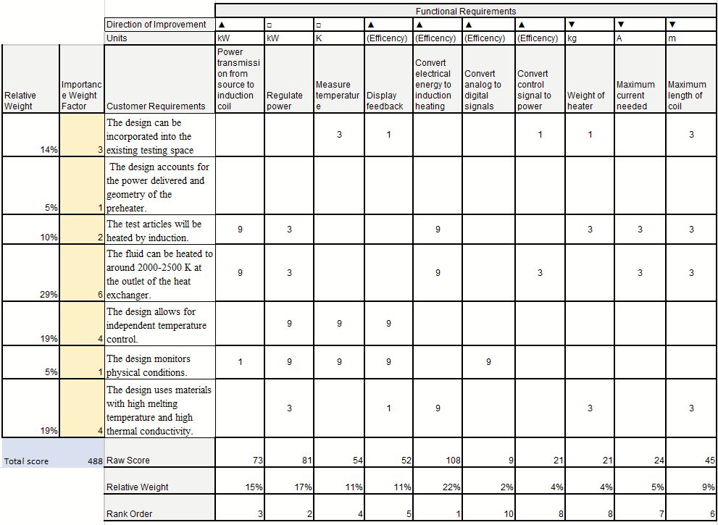

Table 2. House of Quality

The data from the House of Quality is used to determine what engineering characteristics are most important in the final concept based off customer requirements. This allows for the correct choice of design which reflects what the customer wants, thus including the customer’s voice in the selection process.

**First Pugh Chart**

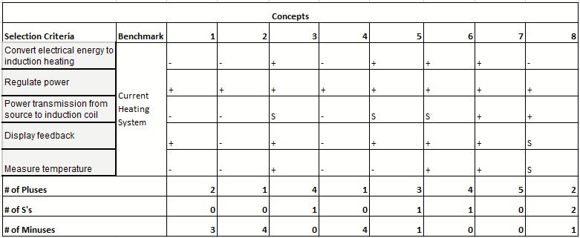

Table 3. First Pugh Chart

The first Pugh chart data allows the determination of how well the concepts compare to the standard solution to solving the problem. In this case, the standard is the existing design. In the first Pugh chart, the 5 medium fidelity and 3 high fidelity concepts were compared to the benchmark. The result was concepts 1,2,4, and 8 were eliminated. The concept with the most S’s and medium number of pluses to minuses was chosen as the next datum as not make an overly difficult benchmark to reach. Since the concepts were so complex, a medium benchmark that was slightly better than the existing design was deemed appropriate by the team.

**Second Pugh Chart**

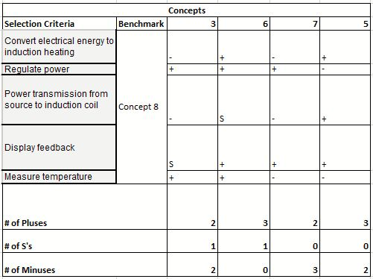

Table 4. Second Pugh Chart

The second Pugh chart features the new datum, Concept 8. It was decided from the second Pugh chart that Concept 6 would work best given the selection criteria because this concept had the highest number of pluses and lowest number of minuses.

**AHP**

The AHP is a more mathematical selection process. The engineering characteristics for this are taken from the House of Quality, based on the importance weight factor. A pairwise comparison for engineering characteristics is made, with the higher rankings signifying a higher importance in terms of the overall goal of the project. The rows are compared with each column, and based on its importance relative to the column, a ranking value is given. For a given cell value, the corresponding cell across the diagonal will have a reciprocal value based on the nature of the comparison.

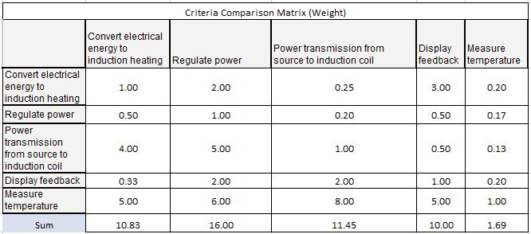

Table 5. AHP Criteria Comparison Matrix

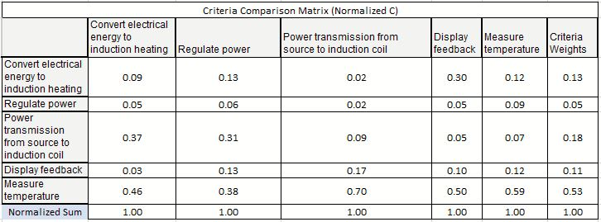

Table 6. Normalized Criteria Comparison Matrix

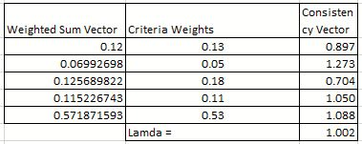

Table 7. Weighted sum vector and consistency vector

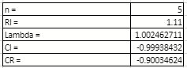

Table 8. Values used to calculate comparison ratio

Based on a comparison ratio lower than 0.1, it was decided that the concepts were not chosen with any bias present.

## 1.8 Spring Project Plan

# Chapter Two: EML 4552C

## 2.1 Spring Plan

### Project Plan.

### Build Plan.

# Appendices

# Appendix A: Code of Conduct

1. **Mission Statement**

Team 514 is dedicated to creating a positive and fun work environment, where knowledge is gained, but professionalism and respect is required. Every member will contribute to creating a product that the team can be proud of.

1. **Team Roles**

Kevin Hartzog – Project Manager/Aero-Thermal Engineer

* Responsible for organizing meetings with sponsor and advisor and maintaining constant communication between the team. Help make design changes go smoothly between roles. Researches and conveys knowledge to group. Assisting in aerodynamic design and forming analysis models.

Michael Corak – Manufacturing Engineer/Test Engineer

* Materials selection and manufacturing lead. Responsible for ordering of parts/tools as needed. Creates test plans for validation of design.

Jordan Weid - Simulation/Structural Design Engineer

* Finite element analysis lead. Works with CAD designers to ensure that designs are validated for future design iterations.

Fisher Hilburn - Mechanical Design Engineer/Systems Engineer

* Responsible for leading CAD related tasks. Coordinates with simulation engineer to optimize design.

For duties such as timeline planning, financial analysis, and other unforeseen roles, the group will share the roles based on current workload.

1. **Integrity and ethics**

Group members are expected to be familiar with and uphold the NSPE Code of Ethics for Engineers. As representatives of the engineering profession, the FAMU-FSU College of Engineering, and the sponsor, the team must uphold these rules.

1. **Attendance Policy**

Attendance is required for every sponsor, advisor meeting, and presentations. Repeated unexcused absences will result in disciplinary action against the group member.

1. **Communication**

The main form of communication between group members will be through text messaging and calls via Zoom. Zoom meetings will be held twice a week for updates and progress reports. Emails will be an alternative in case more in depth communication is required. Email will also be used to transfer files in the group, and physical storage in case files are too large. Communication for sponsor and advisor will be through email. Time when meeting takes place is agreed upon by both parties. Advisor and sponsor meetings will take place bi-weekly.

Within the group, a reply should take less than 24 hours. For advisor and sponsor communication, a reply should take less than 3 business days. If a group member is expected to be absent, they are required to notify the group of the nature of the absence, and estimated duration of the absence. This will always be done before the absence occurs.

1. **Decision Making**

In order to create a fair environment, every team member will always be heard, but decisions will ultimately be decided on consensus. All members will be able to contribute to decisions even if they are not directly involved in the task.

1. **Conflict Resolution**

In the event of disagreement or conflict, the project manager will schedule a group meeting to setup a majority rule vote to solve the issue. If a team member is still in disagreement, a meeting with an instructor will be organized.

1. **Dress Code**

Group members are expected to dress in:

* Casual attire for group and advisor meetings.
* Business casual attire for meetings with sponsor.
* Business attire (suit and tie) for presentations and professional gatherings.

Group members are expected to maintain a clean appearance. Facial hair must be groomed and maintained. Dress that is dictated by religion is not subject to these standards.

1. **Statement of Understanding**

By signing this document, each member agrees to the terms of the Code of Conduct above and will obey them.



# Appendix B: Functional Decomposition

# Appendix C: Target Catalog

|  |  |  |
| --- | --- | --- |
| **Functions** | **Target** | **Metric** |
| Power transmission from source to induction coil | 15 kW | Power |
| Heat transmission from induction coil to test article | 80% Efficient | Q(Heat)_test article / Q_coil |
| Regulate power | 5% of max | Power |
| Measure temperature | <1 kelvin resolution | Temperature |
| 0-2300 kelvin range | Temperature |
| Display feedback | 6-inch digital display | Length |
| Convert electrical energy to induction heating | 84% Efficiency | Q_coil / Current*Voltage |
| Convert control signal to power | <5 second settling time | Time |
| Convert analog to digital signals | 12-bit A/D conversion | Resolution |
| Weight of heater | <470 lbs. | Weight |
| Maximum length of coil | <=12 in. | Length |
| Maximum current needed | 20A-100A | Current |

# Appendix D: Concept Generation

**Control**

1. Potentiometer with transistor temperature controller
2. Relays to switch between different temperatures
3. Microcontroller temperature controller with transistors
4. Radio frequency remote control
5. Voltage control
6. Current control
7. PWM control
8. Automated control through computer program
9. Quantum computer

**Flow**

1. Mechanically throttled valve
2. Passive flow control like casing treatment
3. Electric motor throttled valve like exhaust cutouts
4. Morphable fluid enclosure
5. 3D printed pipe
6. Multiple smaller inlets
7. Blend from rectangular to circular cross section shape
8. Abradable material pipe that changes shape as fluid flows
9. Gate valve
10. Ball valve
11. Pinch valve
12. Diaphragm valve
13. Needle valve

**Heating**

1. Induction and resistive heating combination
2. Gas heating with fuel source
3. Radiative heating with tungsten filament
4. Copper heating element using conduction
5. High frequency induction heating
6. Gas torch
7. Sunlight through magnification lens
8. Fan blowing hot air through coils
9. Sunlight heating water used to transfer heat
10. Nuclear heating
11. CO2 lasers
12. High power diode lasers
13. Microwave heating
14. TNT chemical reaction heating
15. Geothermal heating
16. Methane heating
17. Coal combustion
18. Resistive coil suspended in flow
19. High-temperature heat gun
20. Hydrogen fusion
21. Wood combustion
22. Lava
23. Friction heating

**Mounting**

1. Clamping mechanism
2. Weaver rail style mounting
3. JB weld mounting
4. Shelving brackets
5. 8020 extrusion
6. Unistrut
7. Electromagnetic mounts
8. Mounting stud and brackets
9. Picatinny rail
10. Composite plate with insulated thru holes
11. Suspension mounting
12. 3-point stinger mounting (good for thermal braking)
13. Permanent magnetic mounts
14. Friction based mounting
15. Zip ties
16. Duct Tape
17. Epoxy
18. Superglue
19. Magnetic levitation
20. Chains
21. Lug nuts
22. Systems of struts
23. Truss system
24. Arch bridge
25. Spring and Damper system
26. Metal 3-D printed mount

**Heat exchanging**

1. Topology optimized heat exchanger shape
2. Counter flow heat exchanger
3. Pancake induction coil and radial heat exchanger
4. Helically twisted heat exchanger
5. Spiral induction coil with cone shape heat exchanger
6. Fin heat exchanger
7. Envelope style heat exchanger to maximize surface area
8. U-style induction coil that also acts as cradle mount
9. Rectangular cross section cylindrical heat exchanger
10. Radiant floor with brazed plate heat exchanger
11. U-tube single pass shell
12. Two pass tube single pass shell
13. Two pass tube single pass shell with floating head
14. Rotary regenerator
15. Double pipe with axial fins on inner pipe
16. Hexagonal cross section
17. Termite mound channel-based heat exchanger
18. Liquid metal heat exchanger
19. Cylindrical tubing
20. Solid bar of steel
21. Radiator
22. Metal 3D printed heat exchanger

**Measuring temperature**

1. Thermocouple array
2. Pyrometer with thermocouple
3. Infrared scanner
4. Analog dial
5. Strain gauge
6. Digital Thermometer
7. Mercury thermometer

# References

Electric Power Research Institute (EPRI), Dols, J., Fortenbery, B., Sharp, F., & Sweeney, M. (2014). Induction Cooking Technology Design and Assessment. *ACEEE Summer Study on Energy Efficiency in Buildings.*